**MALIGIREDDY SUSHMA**

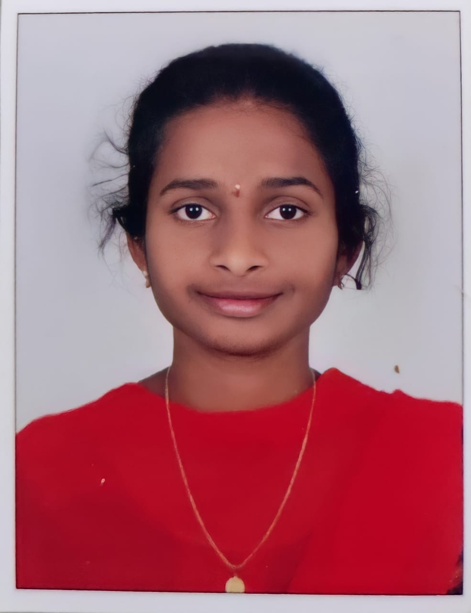

|  |  |
| --- | --- |
| **Title:** | Analyst/Software Engineer |
| **Location:** | Hyderabad, India |
| **Languages:** | Telugu (native),English (fluent), Hindi (fluent) |

# Professional Summary

To pursue a challenging career and be a part of progressive organization which helps to learn and improve my engineering skills and knowledge by working with an organization that provides me with opportunities and challenges. Good communication and interpersonal skills. Well-trained in Dotnet, Java and SQL. Ability to translate business requirements into technical solutions.

**KEY SKILLS:**

* **Functional:**  Attention to details, Effective planning and Organization, Team Building, Multi-tasking, Team coordination, good communication and interpretation skills.Co
* **Technical:** DOTNET, SQL, JAVA, HTML
* **Tools:** Visual Studio, SQL Server
* **Database:** RDBMS

##### 

# Training

* DOTNET Technology

# Certifications & Affiliations

* Certified in Az-900 Microsoft Fundamentals

# Higher Education

Sphoorthy Engineering College 2017-2021 Hyderabad, India

Sri Chaitanya Junior College 2015-2017 Hyderabad, India

Ravindra Bharathi School 2014-2015 Hyderabad, India